Contribution to the statement of the Alliance Autiste (AA) concerning the conference “Affinity Therapy” in Rennes, France

This is a translation of the first part of AA statement, available on the AA blog
(http://allianceautiste.org/wp/2015/02/communique-aa-au-sujet-du-colloque-affinity-therapy-a-rennes/)

To the public authorities (State, social security, regional health agencies, regional councils) who contribute to financing specialised institutions and psychaitric hospital day care, universities and training for health professionals

We take note of the conference on autism titled Affinity Therapy, to be held 5-6 March in Rennes, France.

This conference sub-title claims “Autism – a revolution at work in the USA”.

The content of this conference will be a presentation of a supposed revolutionary therapy, invented and promoted by an American journalist, father of an autistic child. This method is supposedly based on the specific interests of children.

The partners of this conference are the Brittany Regional government, the city of Rennes, the Ile et Vilaine department council, the University of Rennes and the European University of Brittany.

The presentation of this conference leaves us dubious:

In terms of the professional competences of the organising committee

We note that professional psychoanalysts are highly interested in this “new” method

Indeed, most of the organisers are psychoanalysts, with close ties to Freudian and Lacanian movements, and occupying high-level positions in the universities involved.
That said, they’ve almost never published internationally. They offer no scientific proof of the approach they offer, notably a psychoanalytical/psychodynamic approach to autism. [1]
We note that none of the French specialists recognized internationally for their autism research have been invited to this conference.
Equally, no parent association representatives have been invited.

We note that the “Autism Research Group” whose members are nearly all the members of the organising committee have NO references on autism available when searched on the internet.

Nonetheless, it is noted in the presentation [2] that “The research group has been working since many years to get to identify in practice what orients the clinical workers in their diagnoses, then to aggregate and develop institutional experiences based on psychoanalysis in France. The different studies conducted confirm that this is a major axis for the care for autistic children and adults; it seems important to highlight the results of this care to offer evidence of the benefits of this (psychoanalysis) approach.”

We would be curious to learn more about these famous studies, if indeed they exist.

It is indeed curious that a research group that says it has worked for several years in the field has absolutely no references available on internet.

The term “revolution” implies a completely new and promising method.
However, this method is a mixture of three types of therapy (behavioural, cognitive and psycho-dynamic), practices known to all professionals trained about autism. There is nothing revolutionary about it. We do not see what is revolutionary about centring a method on the interests of the child: indeed, the education of the “whole child” is based on the child’s interests.
Furthermore, behavioural therapy has always fully centred its method on the child’s interests, considering that motivation is the motor for all learning. There is absolutely nothing new in this concept.

It is surprising to say the least to discover in this presentation the terms “revolution”, “contemporary approach and practice”, “at the edge of the latest international research”, associated with professionals who practice a psychoanalytical approach to autism : indeed, as one can see in the film, “The Wall: psychoanalysis put to the test for autism” [3], these professionals still associate autism with psychosis provoked by a poor mother/child relationship, and believe that treatment should consist of observing the patient without intervening.

They haven’t evolved their practice since the 1970s, as witnessed by the president of this conference Eric Laurent, quoted in the film The Wall:
”The dialogue with the neurosciences, it is not simply to inform ourselves of results and to insist that we will not change our fundamental way of practicing, or the orientation of our practice, it is to try to allow humanity to live without too much hope in different good news which are published each day(…)”

Among the honoured guests, there are two psychoanalysts who testified in this film, along with JR Rabanel, a psychaitrist/psychoanalyst who I invite you to listen to [4] during a training on autism.

Our feeling is that rather than being at the forefront of international research, these professional organisers are at the point of infiltrating each new strategy which permits them to re-establish their reputation which was tarnished by the film “The Wall” and by the recommendations of best practices published by the public health authority HAS.

On the open-mindedness of the psychoanalyst members of the organising committee

We recognize that these professionals are quite good at pretending to be open to all approaches, to listen to autistic individuals [5], all while showing themselves to be quite the opposite when one examines their concrete actions. As an example, the special guest Alexandre Stevens, interviewed in the film The Wall states
“In the Francophone world, the invasion of cognitive-behavioural techniques is a new invasion, recent but very present these days – psychoanalysis fights against this invasion.”

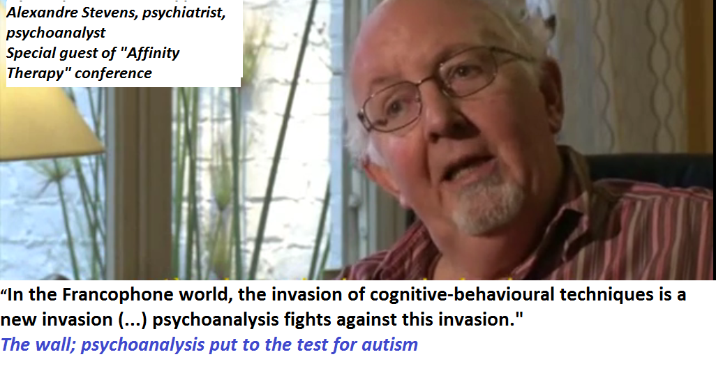

On material written by autistic individuals, misused to promote this method

We refuse that the written work of “high functioning” autistic individuals, cited on p.4 of the presentation materials, be recuperated in support of this type of practice. We could easily cite other, including Daniel Tammet, Temple Grandin, Liane Holiday Willey, to name just a few including the Frenchman Josef Schovanec, who strongly condemn psychoanalysis in their testimonies, as they were victims of this movement!

Some were lucky enough to be heard by professionals who truly wished to have their practices evolve (for example the collaboration between Professor Mottron and Michelle Dawson [6]). This is the type of testimony, concrete and constructive, that we wish to see highlighted at a conference which is supposed to present the latest progress.

On the public expenditures earmarked for psychoanalytical practices in institutions and psychiatric hospital day care

It is disastrous that the public authorities are fooled into associating with such “recycled” theories, whereas the situation of autistic individuals in France is absolutely dramatic.

It is disastrous that public finances are attributed in this day and age to these “professionals” with absolutely no control by the State, with budgets which are renewed each year with no counterparty of performance, and a total opacity concerning the financing in the millions of euros[7], spent by the social security administration.

Concretely, the care given in these institutions and psychiatric hospital day care facilities does not respond at all to the recommendations given by the public health authorities (HAS) concerning autism [8].

It is truly scandalous that public funds are thus wasted, while at the same time parents fight and indebt themselves to create and manage educational centres within which their children progress but with no public financial support.

Consequently, we demand that the public authorities immediate stop wasting money in such practices, and redeploy the public funds towards practices which meet the recommendations of the public health authority (HAS).

We demand the end to this scandalous situation, which over the past decades has led to human disaster brought on by the total loss of opportunity for autistic individuals and their families.

[1] The recommendation mentions that « the absence of data on the effectiveness and the divergence of opinions does not allow us to conclude that there is any pertinence in therapies based on the psychoanalytical approach”.
[2] Press package, page 2

[3] This documentary film exposes the psychoanalytical view of autism, via interviews with 10 psychoanalysts and a paediatrician who is close to the Lacanian movement. For the first time, these professionals express their theories in a language accessible to the non-initiated. In front of Sophie Robert’s camera, they explain their intimate convictions on what they believe causes autism : a psychosis induced by a bad relationship between mother and child, and offer as a psychoanalytical solution therapeutic nihilism, with consequential institutionalisation for life in psychiatric institutes.
[4] Quote from a conference given by Jean Robert Rabanel – “What are we speaking about when we say autism”, the Institute of Social Work of the Auvergne region, 11 April 2013
[5] Written work by autistic individuals were psychoanalysed and published in a book, “Listen to the autistic people” by JC Malleval, psychoanalyst and member of the organising committee.
[6]A. Pélouas, « Autisme, changer le regard », Le monde, 16/12/2011, URL : http://www.lemonde.fr/planete/article/2011/12/16/autisme-changer-le-regard_1619381_3244.html

[7] The chair of the parliamentary group on autism prepared a budgetary projection in 2012, estimating at approximately 13 billion euros the potential savings over the lifespan of the 8000 autistic children who are born each year if the government reimbursed 25 hours per week for a trained one-on-one aid during 16 years (from 2 to 18 years old), rather than institutionalised the children.

